System Designed Document
For
Community Connect (Group 3)

Group Members:
Surname | Names | Student No
HOMU | NHLAWULEKO ORIEL | 201911052
MASEKO | VELAPHI SILINDILE | 202036211
MOKOELE | MASHAO ANDRE | 201951302
NALEDZANI | MUTSHUTSHU THABELO | 201817016
RAMONTSHA | MAKGALANE INNOCENT | 202000982
MATSHIPA | EDWIN | 201914329
SEKOKOTLA | KAGISO PERCY | 201825048
CHAUKE | HLAMULO | 201726900
Version 1.0
28 August 2023

Table of Contents
Table of Contents 2
1. Document Overview 2
Scope 2
Audience 4
Related Documentation 5
Document Conventions 6
2. System Overview 7
Description 7
System Architecture 8
Software Architecture 9
Hardware Architectures 9
3. Hardware Design 11
Hardware Components 11
Computer Systems 12
Peripherals 13
Networks 15
Project Specific hardware items 16
Hardware Integration 16
Logical Design 16
Physical Design 17
Recovery Design 18
4. Software Design 19
Software Packages 19
Software Integration 21
5. Data and Database / Files 23
i. Data Flow Diagrams 23
ii. Database Design (ERD) 25
Files 26
System Parameters 26
6. System Interfaces 26
7. System Performance 30
8. Glossary / Terminology 31
9. references 32

Document Overview

Scope
This Software Design Document (SDD) outlines the detailed design aspects of the Community Connect platform, which aims to create a dynamic digital space for community members to communicate, collaborate, and engage. The document covers the software and hardware components, interfaces, and data structures required for the implementation of the platform.

Hardware:
Computer Systems:
The platform is designed to run on smartphones and tablets. It is compatible with the Android operating system.
Peripherals:
The platform interacts with various peripherals such as cameras and input devices to facilitate data input, output, and communication.
Networks:
The platform relies on network infrastructure, including routers, and internet connectivity, to ensure seamless online access for users.

Software:
Software Packages:
The platform is composed of multiple software modules and packages that collectively provide its diverse features and functionalities.
Operating Systems:
The platform is compatible with the android operating system.
Application Programming Interfaces (APIs):
The platform integrates with external services through APIs, including email services and payment gateways.
Database Management Systems:
The platform utilizes database management systems to store and manage user data, event information, emergency alerts, and fundraising campaigns.

User Interface Components:
The platform's user interface includes interactive components that allow users to engage with features such as event creation, emergency alerts, fundraising campaigns, and community forums.

The scope also includes the creation and maintenance of interfaces with external systems and services, ensuring seamless data exchange and functionality. The Community Connect platform aims to serve community members, community organizations, and moderators by providing a user-friendly, efficient, and integrated platform for communication, event management, emergency response, and fundraising.

Audience
The intended audience for this SDD includes software developers, system architects, software engineers, project managers, and stakeholders who are involved in the development and implementation of the Community Connect platform. Readers are expected to have a background in software development, system architecture, and project management.
Skills Required:
The document is tailored for professionals who possess the following skills and expertise:
Software Development:
The audience should be well-versed in software engineering principles, programming languages, and software design patterns. They should have experience in developing and integrating software modules to build complex systems.
Hardware Integration:
Familiarity with hardware components, peripherals, networks, and integration techniques is essential. The audience should understand how different hardware elements interact to create a cohesive system.
System Architecture:
The audience should have a solid understanding of system architecture concepts, including software and hardware integration, system interfaces, and system performance considerations.

Database Design:
Proficiency in database design principles, entity-relationship diagrams (ERDs), and data modeling is required to comprehend the database-related sections of the document.
Networking:
An understanding of networking protocols, data flow, and network integration is necessary to grasp the network-related aspects of the project.
Security and Privacy:
Knowledge of security best practices, authentication mechanisms, data encryption, and user privacy considerations is crucial to understand the security measures implemented in the platform.
Assumptions:
It is assumed that the audience possesses the technical background and expertise described above. Additionally, it is assumed that the audience is familiar with software development methodologies, system design principles, and relevant industry standards. Familiarity with documentation practices and the ability to read technical diagrams, such as data flow diagrams and entity-relationship diagrams, is also assumed.
The audience is expected to have access to the related documentation, such as the System Requirements Specification (SRS), the Requirements Analysis Document (RAD), and any supplier documentation related to hardware and software components.
Overall, this document is intended for technical professionals who are actively involved in the design, development, and implementation of the Community Connect platform. It provides a detailed and comprehensive view of the project's technical aspects, enabling the audience to effectively contribute to the successful realization of the platform.

Related Documentation
This section provides a list of related documents that complement and support the detailed system design of the Community Connect platform. These documents serve as references for understanding various aspects of the project and ensuring alignment with the broader project objectives.
- Software Requirements Specification (SRS):
This document outlines the functional and nonfunctional requirements of the Community Connect platform, providing a foundation for the design and development process.
- Requirements Analysis Document (RAD):
The RAD provides an understanding of the project's purpose, audience, scope, and objectives. It also offers insights into the community's needs and the envisioned functionalities of the platform.

Document Conventions
This section outlines the diagrammatic notation and conventions used throughout this document to represent the architectural views by using Unified Modeling Language (UML) diagrams, system components, and interactions. Clear and standardized notations aid in understanding the design and ensure consistency in communication across the project team.
Unified Modeling Language (UML):
The Unified Modeling Language is the primary notation used in this document to depict system architecture, interactions, and design components. UML provides a standardized set of diagrams that convey various aspects of the system's structure and behavior.
The following UML diagrams are used in this document:
- Use Case Diagrams:
Use case diagrams represent the interactions between actors (users or external systems) and the system's use cases. They visually depict how users interact with the system and the functionalities provided by the system.
- Class Diagrams:
Class diagrams illustrate the static structure of the system by depicting classes, attributes, methods, and their relationships. These diagrams help in understanding the organization of classes and their interactions.
- Sequence Diagrams:
Sequence diagrams showcase the dynamic interactions among objects and components over time. They visualize the sequence of messages exchanged between objects during specific scenarios.
- Component Diagrams:
Component diagrams illustrate the physical arrangement of components in the system, showing the relationships and dependencies between them. These diagrams aid in understanding the high-level system structure.

- Deployment Diagrams:
Deployment diagrams provide insights into the physical deployment of software components on hardware nodes. They show the distribution of components across different servers or devices.

System Overview

Description
The Community Connect platform is a dynamic digital space designed to foster communication, collaboration, and engagement among diverse community members. It serves as a virtual hub that transcends geographical boundaries, enabling users to interact, share ideas, organize events, and respond swiftly to emergent needs. By harnessing modern technology, the platform aims to create a heightened level of connectivity that enriches the community experience and cultivates a sense of unity and shared purpose.

The platform's primary goal is to overcome the limitations of traditional communication channels, offering an innovative solution that empowers individuals to connect, regardless of their physical locations. With features such as event management, emergency alerts, user profiles, and donation processing, Community Connect seeks to streamline community interaction and empower members to collaborate on initiatives that contribute to the community's well-being.
KEY CONCEPTS:
- Community Interaction:
The platform empowers users to interact and collaborate in meaningful ways. Through features like Community Forums, users can engage in discussions, share insights, and connect with fellow community members.
- Event Coordination:
Community members can easily create, manage, and participate in a diverse range of events. The Event Management feature enables users to organize workshops, gatherings, and activities, fostering community involvement.
- Emergency Alert System:
Safety is a priority. The platform features an Emergency Alert System that allows authorized users to rapidly communicate critical information to all community members during emergencies. Users receive instant notifications and can acknowledge their safety status.
- Secure Donation Platform:
The platform facilitates impactful fundraising campaigns. Users can contribute to campaigns, track progress, and gain transparency into how raised funds are being utilized, driving community support for important causes.
- Volunteer Matchmaking:
Community organizations can post volunteer opportunities, matching individuals with projects that align with their skills and interests. This encourages active community involvement and collaboration.
- User Recognition and Rewards:
The platform recognizes and rewards active community members and volunteers, fostering a sense of belonging and encouraging continued engagement.
- Privacy and Security:
User data privacy and security are paramount. The platform adheres to strict data protection regulations, ensuring that users' personal information remains confidential and secure.
EXTERNAL INTERFACES:
The Community Connect platform interfaces with the following external entities:
- Users:
Community members, community organizations, and moderators interact with the platform through intuitive mobile interfaces. They utilize various features to engage, contribute, and communicate within the community.
- Emergency Authorities:
Authorized personnel can access the Emergency Alert System to swiftly disseminate critical alerts to the entire community during emergencies. This ensures the rapid communication of essential information.
- Payment Gateways:
The Secure Donation Platform interfaces with secure payment gateways, enabling users to make donations using various payment methods, including credit cards, and mobile wallets.

System Architecture
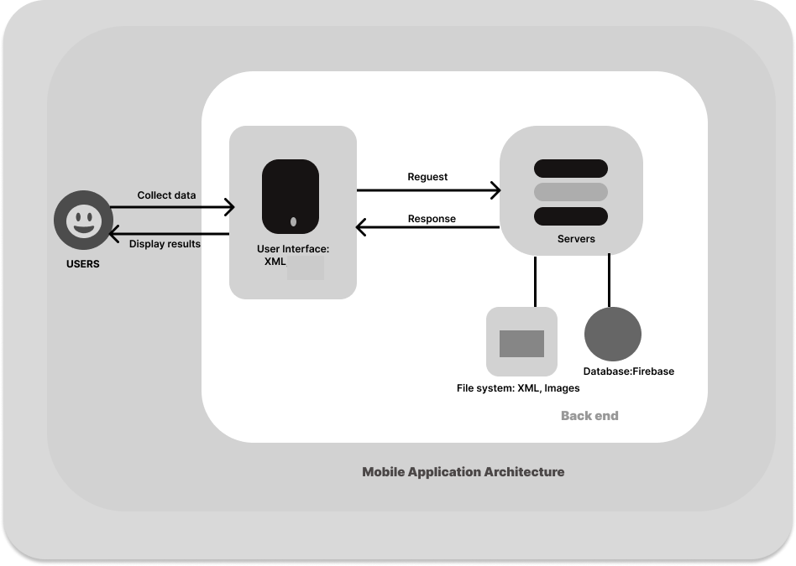
The Community Connect platform's system architecture is designed to provide a comprehensive and cohesive ecosystem that seamlessly integrates various software components, ensuring effective communication, data sharing, and user interaction. The architecture is developed to support the platform's diverse functionalities, including community engagement, event management, emergency response, fundraising campaigns, and more. It encompasses both software and hardware components, all working together to create a unified user experience.

Software Architecture
The software architecture of the Community Connect platform is structured in a modular and scalable manner, allowing for flexibility and ease of maintenance. The architecture follows a multi-tiered approach, separating components based on their roles and responsibilities:
- Presentation Layer:
This layer is responsible for the user interface and interaction. It includes mobile app interfaces that allow users to access and interact with various platform features, such as event creation, emergency alerts, fundraising campaigns, and community forums. The user interface is designed to be intuitive, responsive, and user-friendly.
- Application Layer:
This layer contains the core business logic and functionality of the platform. It includes various software modules and components that handle user registration, authentication, event management, emergency alerts, fundraising campaigns, and more. These components ensure the proper functioning and coordination of different platform features.
- Data Layer:
The data layer handles data storage and management. It consists of a relational database management system (DBMS) that stores user profiles, event information, emergency alerts, fundraising campaigns, and other relevant data. The data layer ensures data integrity, security, and efficient retrieval.
- Integration Layer:
The integration layer facilitates communication between different software components and external services. It includes APIs (Application Programming Interfaces) that enable interactions with third-party services, such as email providers and payment gateways. This layer ensures seamless data exchange and integration with external systems.

Hardware Architectures
The hardware architecture of the Community Connect platform is designed to support the software components and ensure optimal performance, scalability, and reliability. It encompasses various elements including platforms, networks, peripherals, and their integration:
- Server Platforms:
The platform's software components are deployed on cloud-based server platforms. These platforms offer scalability, automatic load balancing, and on-demand resource allocation to handle varying user loads. Multiple virtual machines ensure redundancy and fault tolerance, minimizing service disruptions.
- User Devices:
The platform is accessible through a variety of user devices, including smartphones, and tablets. The responsive design of user interfaces allows users to access the platform seamlessly from different devices, ensuring a consistent user experience.
- Data Storage and Databases:
The platform's data is stored in highly available and redundant databases. These databases are designed to handle large volumes of data and ensure data integrity. Automated backups and failover mechanisms ensure data durability and availability.
- Peripherals:
Peripherals include devices like cameras that enhance the functionality of the platform. Several peripherals may be integrated to support functionalities such as event check-ins, and media uploads.
- Integration of Hardware and Software:
The integration of hardware and software components is facilitated through APIs (Application Programming Interfaces). These interfaces allow seamless communication between the software modules and the underlying hardware, enabling functionalities such as email notifications, payment processing, and real-time data synchronization.
- Security Infrastructure:
Authentication is implemented to safeguard user data and system integrity. Multi-factor authentication mechanisms enhance the security of user accounts and sensitive transactions.

- Scalability and Redundancy:
The architecture is designed to support scalability and redundancy. This includes the ability to dynamically allocate additional resources during peak usage periods and replicate critical components to ensure uninterrupted service in case of hardware failures.

Hardware Design
This section outlines the detailed design and integration aspects of each hardware component in the Community Connect platform. It discusses the hardware design criteria, approach, customization, environmental requirements, target location, physical dimensions, configuration parameters, integration requirements, and other relevant design information for each hardware component.

Hardware Components
The Community Connect platform's hardware design encompasses the following components that contribute to the seamless operation and interaction of the system:
- Make/Model:
Various user devices including smartphones, and tablets from different manufacturers.
- Database Servers:
A dedicated database server hosts the platform's database management system, which stores user profiles, event details, emergency alerts, and donation records. The server employs high-speed storage solutions to ensure rapid data retrieval and manipulation, enhancing the overall user experience.

- Networking Components:
Networking components including routers, ISP play a crucial role in maintaining seamless communication between various system components and external entities. The platform's network architecture is designed to handle high volumes of data traffic securely, providing users with uninterrupted access to the system.

- Mobile Devices:
The platform supports mobile accessibility through Android devices. The hardware design ensures compatibility with a range of Android smartphones and tablets, enabling community members to engage with Community Connect while on the move. Mobile devices provide users with the flexibility to access event details, emergency alerts, and community updates.

Computer Systems
The Community Connect platform's computer systems are fundamental to its successful operation, ensuring efficient and reliable hosting of the software application and database. The platform is designed with considerations for availability, fault resilience, performance, and scalability.
Platform Types and Hardware Standards:
- The application and database will be hosted on cloud-based servers provided by Firebase, a widely used and reliable cloud platform.
- The hardware infrastructure and standards are managed by Firebase, ensuring compatibility and optimal performance.
Operating System and Software:
- The servers provided by Firebase are managed and abstracted, meaning the underlying operating system and software are maintained by the platform.
Database Management:
- Firebase provides a real-time NoSQL database that enables seamless data synchronization across clients and allows for efficient handling of user-generated data.
Availability and Fault Resilience:
- Firebase offers built-in redundancy and high availability features, ensuring that the platform's data and services are accessible even in the event of hardware or software failures.
- Firebase's managed services include automatic failover mechanisms and data replication across multiple geographic locations.
Scalability:
- Firebase offers auto-scaling capabilities, which means the platform can handle increased user loads by dynamically allocating resources as needed.
Performance Optimization:
- Firebase's database and hosting services are optimized for performance, providing low-latency data access and fast response times for user requests.
- Caching mechanisms are utilized to reduce the load on the database and enhance overall system performance.
Network Connectivity:
- Firebase servers are connected to high-speed and redundant network connections to ensure fast data transmission and minimal latency.
Security and Compliance:
- Firebase provides security measures such as authentication, data encryption, and access control to protect sensitive user data.
- The platform complies with industry-standard security practices to safeguard user information.
Monitoring and Management:
- Firebase offers monitoring and analytics tools that allow administrators to track system performance, user engagement, and other relevant metrics.
Power Redundancy:
- Firebase's infrastructure is equipped with power redundancy mechanisms, including uninterruptible power supplies (UPS) and backup generators, to ensure continuous operation.
Data Backup and Recovery:
- Firebase automatically performs regular backups of data, reducing the risk of data loss and ensuring data integrity.

Peripherals
The Community Connect platform incorporates a variety of peripheral devices and associated components to enhance its capabilities and provide a seamless user experience. These peripherals facilitate data exchange, storage, and interaction within the system. While the platform primarily operates on Android devices, certain backend and data storage components are also integrated. The following is a list of peripherals and associated components used in the platform:

Android Devices:
- Smartphones and tablets running the Android operating system.
- Touchscreen displays, cameras, microphones, GPS, sensors, and internet connectivity.
Backend Servers:
- High-performance servers to host the application's backend services and databases.
- Ensures data processing, user authentication, and data storage.
Firebase Database:
- Cloud-based NoSQL database offered by Firebase for efficient data storage and retrieval.
- Provides real-time synchronization and offline capabilities for mobile applications.
Internet Connectivity:
- Ensures communication between Android devices and backend servers.
- Utilizes various communication standards, including cellular data and Wi-Fi.
Cameras:
- Integrated cameras in Android devices for capturing images within the application.
- Allows users to share visual content and participate in multimedia-based interactions.
Storage Devices:
- Utilizes internal storage and expandable storage options in Android devices for data storage.
- Stores files, images, documents, and application data.
Internet Protocols:
- Utilizes standard internet protocols such as HTTP and HTTPS for secure communication between devices and servers.
- Facilitates data exchange and API requests.
Notification Services:
- Integrates Android's notification system for delivering alerts, updates, and event-related notifications to users.
- Ensures timely communication and user engagement.
Battery Management:
- Android's battery management system to optimize battery consumption during platform usage.
- Ensures efficient device operation while conserving battery life.

Networks
The network architecture of the Community Connect platform is designed to provide seamless communication and data exchange between the mobile application, backend servers, and external services. The following network components and capabilities are essential to ensure efficient connectivity and data transmission:
Routers and ISP:
- Routers manage data traffic between different networks, directing data packets to their intended destinations.
Internet Connectivity:
- Internet Service Providers (ISPs) offer high-speed internet connectivity, allowing access to Firebase cloud services and external resources.
Data Rates and Protocols:
- The platform supports modern communication protocols, such as HTTP, HTTPS, and WebSocket, ensuring secure and rapid data transmission.
- Data rates depend on the available internet connection speed and Firebase's cloud infrastructure capabilities.
Firebase Backend:
- Firebase serves as the cloud-based backend, managing data storage, user authentication, and real-time communication.
- Firebase's robust backend services handle data synchronization, user management.
Security Protocols:
- Secure Sockets Layer (SSL) and Transport Layer Security (TLS) protocols encrypt data during transmission between the mobile app and Firebase backend.
- Encryption ensures data confidentiality and integrity.
Mobile Networks and Wi-Fi:
- The mobile app connects to mobile networks (3G, 4G, 5G) and Wi-Fi networks for data transmission.
Mobile networks provide connectivity on the go, while Wi-Fi offers faster connections in specific locations.

Project Specific hardware items
The Community Connect platform integrates various project-specific hardware items to enhance its functionality and provide advanced features to users. These hardware components contribute to the seamless operation and effectiveness of the platform. Some of the key project-specific hardware items include:
Mobile Devices (Smartphones):
- Android devices serve as the primary interface for users to access the Community Connect mobile application.
- Smartphones and tablets provide a platform for users to interact with the app's features and functionalities.
Cameras:
- Built-in cameras in mobile devices are utilized for capturing images and videos to enhance event documentation and user engagement.
Push Notification Devices:
- Mobile devices are equipped with push notification capabilities to send alerts, updates, and announcements to users in real time.
Networking Hardware:
- Network components such as Wi-Fi modules enable mobile devices to connect to local networks and the internet for seamless data exchange.

Hardware Integration
The hardware integration of the Community Connect platform involves the careful assembly and configuration of various hardware components to create a cohesive and functional system. This integration process ensures that all hardware elements work together seamlessly to support the software applications and achieve the project's objectives. The integration is guided by the logical and physical design considerations, ensuring that the system operates reliably and efficiently. They are outlined as follows:

Logical Design
- Logical Design:
The logical design of hardware integration within the Community Connect platform ensures a coherent and efficient arrangement of hardware components to support the functionalities of the system. The integration follows a client-server architecture, where mobile devices (clients) interact with the Firebase server for data exchange and processing. The logical design includes:
- Client-Server Interaction:
Mobile devices serve as clients that interact with the Firebase server. The logical interaction involves authentication, data retrieval, and data submission through APIs.
- Data Flow:
Users interact with the mobile app's user interface to trigger actions. The app communicates user inputs to the server, which processes requests and responds with relevant data or updates.
- Push Notifications:
Push notification devices enable the server to send alerts and updates to users' devices based on user preferences and events.
- Camera Integration:
Cameras on mobile devices allow users to capture images that can be uploaded and stored on the server.

- Database Integration:
Database servers are seamlessly integrated with the platform's servers to provide efficient data storage and retrieval. The database management system is designed to handle concurrent transactions while maintaining data integrity and security. Integration between database servers and application servers is optimized for fast data access.

Physical Design
The physical design involves the arrangement of hardware components and the required cabling and connectors to ensure seamless hardware integration within the Community Connect platform. The integration follows these steps:
- Mobile Devices:
Android devices are used as clients and are equipped with the necessary connectors for charging and data transfer.
- Push Notification Devices:
Mobile devices are connected to the internet through Wi-Fi or cellular networks to enable push notifications.
- Cameras:
Mobile devices come with built-in cameras that can capture images for integration with the app.

Recovery Design
The recovery design focuses on ensuring hardware availability and system resilience in case of hardware failures. The design includes redundancy and failover mechanisms to minimize downtime. The Firebase server's redundancy and backup mechanisms ensure data availability and recovery in case of server failures.

- Redundancy and Failover:
Critical hardware components are equipped with redundancy mechanisms, ensuring that if one component fails, another takes over seamlessly. Failover procedures are established to minimize service disruption.

- Data Backup and Recovery:
Regular data backups are performed to preserve critical user data. Backup systems are integrated to provide quick data recovery in case of database or hardware failures.

- Disaster Recovery Planning:
A comprehensive disaster recovery plan outlines procedures for restoring the system to full functionality in case of catastrophic events. This plan includes backup data recovery, hardware replacement, and testing procedures.

Software Design
The software design section provides an in-depth exploration of the architecture and design of each software component within the Community Connect platform. These components are meticulously crafted to fulfill specific functionalities and seamlessly integrate to create a cohesive and efficient system. The section outlines the intricate details of each software module, their interactions, data flow, and integration points.

Software Packages
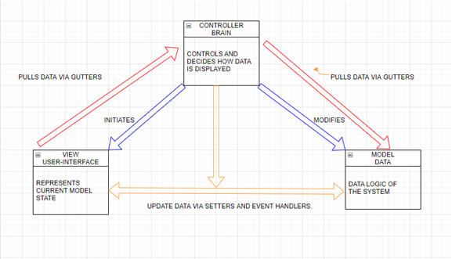
The software packages/modules serve as the building blocks of the Community Connect platform, each contributing to its overall functionality. Here, we delve into the comprehensive overview of the primary software packages/modules:

- User Management Module:
- Purpose: This module handles user registration, authentication, and profile management.
- Functions: Manages user account creation, login, authentication, and profile updates.
- Language/Implementation: Developed using Java and integrated with Firebase Authentication.
- Execution Location: Embedded within the Android app, communicating with Firebase services.
- Data Definitions: Manages user credentials, profile information, and access permissions.
- Interface References: Interfaces with the Firebase Authentication API and the Database module.
- User Relationships: Empowers administrators and community members with secure access.
- Error Handling: Addresses authentication errors, registration issues, and ensures data security.
- Source Files: UserManager.java, AuthenticationHelper.java

- Event Management Module:
- Purpose: This module enables users to create, join, and manage community events.
- Functions: Facilitates event creation, scheduling, participant management, and notifications.
- Language/Implementation: Developed using Java and integrated with Firebase Realtime Database.
- Execution Location: Integrated within the Android app, connecting to Firebase services.
- Data Definitions: Manages event details, participant lists, and scheduling information.
- Interface References: Interfaces with the User Management and Notifications modules.
- User Relationships: Engages event organizers, participants, and administrators.
- Error Handling: Ensures event creation accuracy, participant tracking, and data consistency.
- Source Files: EventManager.java, EventDetailsActivity.java

- Emergency Response Module:
- Purpose: This module allows users to report emergencies and receive assistance.
- Functions: Provides emergency alerts, real-time location sharing, and communication tools.
- Language/Implementation: Developed using Java and integrated with Firebase Realtime Database.
- Execution Location: Part of the Android app, connecting to Firebase services for real-time updates.
- Data Definitions: Manages emergency reports, user locations, and communication logs.
- Interface References: Interfaces with User Management and Notifications modules.
- User Relationships: Empowers users to report emergencies and coordinate with responders.
- Error Handling: Ensures accurate emergency reporting, rapid alerts, and reliable communication.
- Donation Processing Module:
- Purpose: This module facilitates secure processing of donations for community initiatives.
- Functions: Integrates with payment gateways, handling diverse payment methods.
- Data Security: Ensures donor information is managed securely.
- Real-time Tracking: Provides updates on fundraising campaign progress in real-time.
- Implementation: Utilizes a combination of server-side scripting and payment gateway APIs.
- Execution Location: Operates on the organization's mobile platform.
- Data Management: Manages donor details, transaction records, and campaign statuses.
- Interface Connections: Interfaces with User Authentication and Campaign Management modules.
- User Engagement: Enables donors to contribute securely and stay informed about campaign goals.
- Error Handling: Ensures accurate payment processing and reliable progress tracking.

Software Integration
The software integration within the Community Connect platform involves establishing robust linkages that facilitate seamless interactions among different software packages, including Commercial Off-The-Shelf (COTS) components. These linkages are designed to ensure efficient data exchange, synchronization, and collaboration among various modules. Additionally, configuration and customization are addressed to tailor the platform to the specific needs of the users.
Integration Linkages:
- User Management and Event Management Integration:
- Linkage: The User Management module and the Event Management module are linked to ensure that users can register, login, and participate in community events.
- Interaction: When a user registers or logs in, their authentication status is synchronized with the Event Management module to manage event participation.
- Event Management and Emergency Response Integration:
- Linkage: The Event Management module and the Emergency Response module are integrated to enable users to report emergencies during events.
- Interaction: During an event, users can trigger emergency alerts, which are associated with the event details and location data from the Event Management module.
- Notifications Integration:
- Linkage: The Notifications module is integrated with various modules to provide users with real-time alerts and updates.
- Interaction: When a new event is created, participants receive notifications about event details. In the Emergency Response module, users receive alerts during emergencies

Configuration and Customization:
- COTS Integration:
- Description: The Community Connect platform integrates third-party COTS components, such as Firebase for authentication, real-time databases, and cloud storage.
- Customization: Firebase is configured to align with the platform's requirements, including user authentication settings, database structures, and cloud storage quotas.
- Middleware Tools for OR Mapping:
- Description: Middleware tools are employed for Object-Relational (OR) mapping, ensuring seamless interaction between the application's object-oriented code and relational databases.
- Integration: Middleware tools such as Hibernate are configured to handle object-relational mapping, allowing Java objects to be stored and retrieved from the Firebase Realtime Database.

Data and Database / Files
The Community Connect platform comprises various software modules that interact with data repositories to deliver its functionalities. Below is an overview of the software modules and their linkages to data repositories:
- User Management Module: Manages user registration, authentication, and profile information. Links to the "User Profiles" database for storing user data.
- Event Management Module: Handles the creation, management, and participation in community events. Links to the "Events" database for event details and registrations.
- Donation Module: Facilitates fundraising campaigns and donations. Links to the "Donations" database for tracking contributions and campaign progress.
- Post Creation Module: Enables users to create and share posts. Links to the "Posts" database for storing post content and user interactions.
- Notification Module: Manages push notifications to users. Links to the messaging system for distributing notifications.
- Admin Dashboard Module: Provides administrators with tools to manage the platform. Links to various databases and repositor.
- Summary of top-level (DFD).
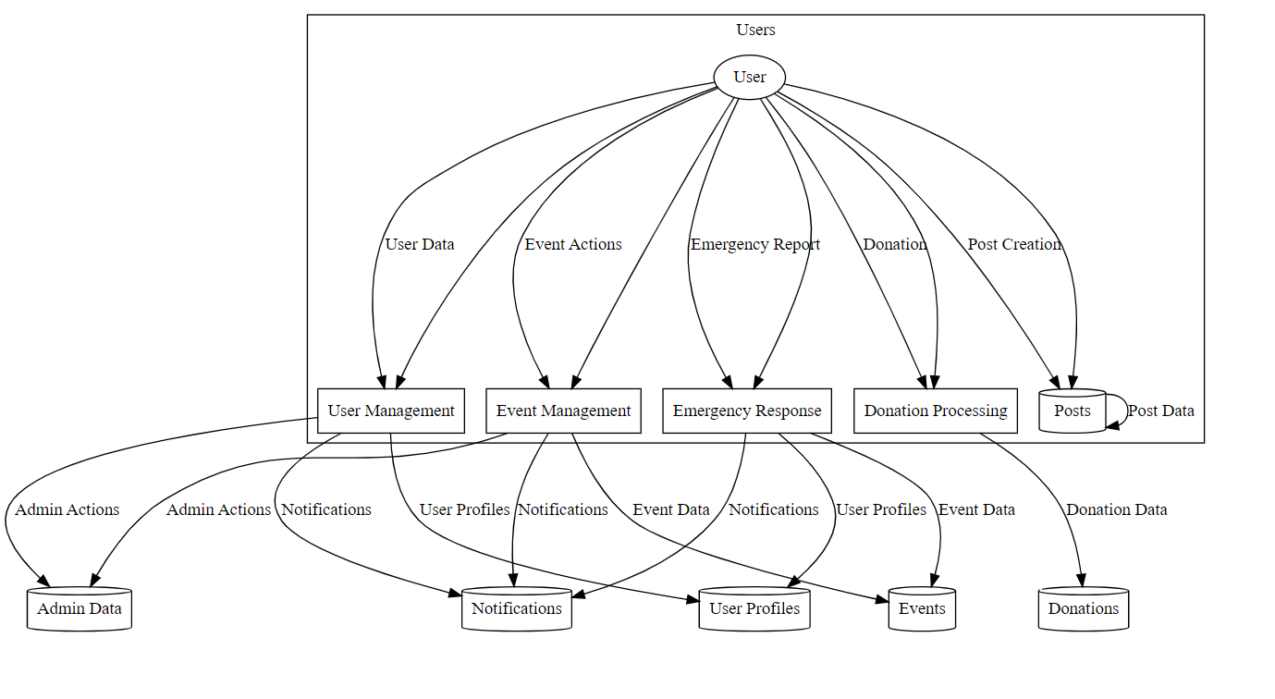
Fig1. Summary of top-level diagram explaining how users interact with functions and databases.

- System level (DFD).
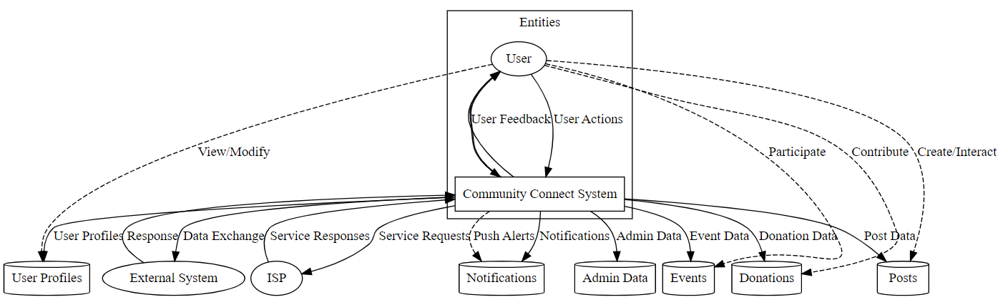

Fig2. Summary of system level diagram explaining how users interact with functions and databases and external systems.

Database Design (ERD)
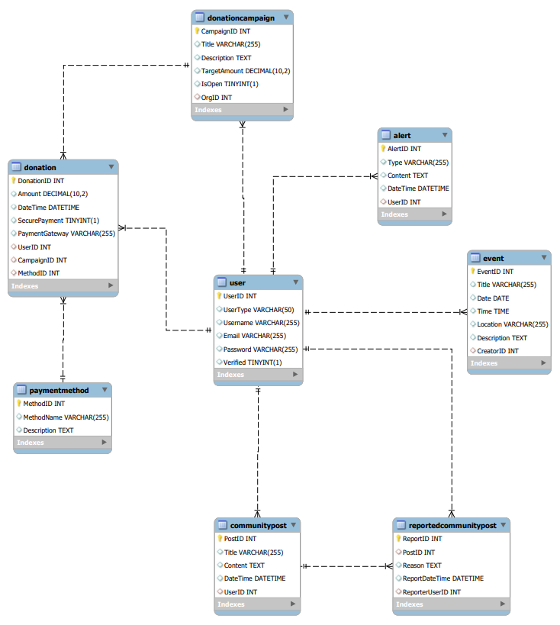
Fig3. ERD visual representation of relationships between entities, and attributes associated with entities.

Files
The files within the Community Connect app project are organized following a structured directory hierarchy to ensure effective management and maintainability. This section provides an overview of the directory structure, key files, and their formats as documented in the Configuration Management/Data templates. These templates ensure consistency in the organization of files and provide a reference for team members to locate and understand the purpose of each file.

1. Directory Structure:
/src
/user_management
/event_management
/donation_module
/post_creation
/notification_module
/admin_dashboard

res/: Stores resource files including layouts, images, strings, and values.
assets/: Holds additional asset files like fonts, XML.
gradle/: Files related to the Gradle build system.

wrapper/: Contains Gradle wrapper files used for project builds.
app/google-services.json: Configuration file for integrating Firebase services with the app.

/docs
/user_manuals
user_guide.pdf: User manual for Community Conn
/developer_docs
api_documentation.md: API documentation for developers

Key Files and Their Formats:

MainActivity.java (app/src/main/java/com/example/communityconnect/): Main activity class for the Android app. Format: Java.
activity_main.xml (app/src/main/res/layout/): Layout XML for the main activity. Format: XML.
strings.xml (app/src/main/res/values/): String resources for localized texts. Format: XML.
google-services.json (app/): Firebase configuration file for connecting the app to Firebase services. Format: JSON.
app_logo.png (app/src/main/res/drawable/): App logo image. Format: PNG.
user_profile.png (app/src/main/res/drawable/): Default user profile image. Format: PNG.
Database rules.rules: Firebase Realtime Database security rules. Format: Firebase Rules Language.

System Interfaces
The Community Connect platform interfaces with various external systems to enable seamless communication, data exchange, and integration. This section defines the interfaces between the Community Connect system and other subsystems, including their descriptions, protocols, data definitions, error handling, and more.

User Authentication Interface
Description: The User Authentication Interface facilitates communication between the Community Connect platform and the Firebase Authentication service for user authentication and management.
Hardware Interrupts: N/A (Software-triggered communication)
Triggering Event: Occurs when a user attempts to log in or register on the Community Connect app.
Message Protocol: Utilizes Firebase Authentication API endpoints and protocols.
Handshaking:
  - User logs in or registers on the app.
  - The app sends authentication requests to Firebase Authentication.
  - Firebase Authentication responds with authentication status or user creation confirmation.
Record/Data Definitions: User credentials, authentication tokens, user profiles.
Timing Restrictions/Frequency: Authentication occurs on user login or registration events.
Queuing/Buffering: Not applicable; authentication is real-time.
Error Identification/Handling/Recovery: Failed authentication attempts are logged, and users are notified. Recovery involves accurate credentials.
Priority: High priority for secure user access.
Flow-Control: Authentication initiated by user action on the app.
Data Transfer Rate: Optimized for quick authentication.
Security and Capacity/Volume: Uses secure HTTPS and Firebase's built-in authentication mechanisms. Scalable to handle user login traffic.

User Post Notification Interface
Description:
The User Post Notification Interface connects the Community Connect app with Firebase Cloud Messaging (FCM) to send push notifications for user-generated posts.

Triggering Event: Occurs when a user creates a new post in the app.
Message Protocol: Utilizes Firebase Cloud Messaging API for push notifications.

Handshaking:
  - A user creates a new post in the app.
  - The app sends an API request to Firebase Cloud Messaging.
  - FCM sends push notifications to relevant app users.

Record/Data Definitions: Post content.
Timing Restrictions/Frequency: Dependent on the frequency of user-generated posts.
Queuing/Buffering: This is not applicable as the push notifications are real-time.
Priority: Moderate priority for notifying users about new posts.
Flow-Control: Initiated by users creating new posts.
Data Transfer Rate: Optimized for efficient push notification delivery.
Security and Capacity/Volume: Secured by FCM and Firebase authentication. Scalable to handle push notifications for user-generated posts.

Event Data Interface
Description: The Event Data Interface connects the Community Connect app with the Firebase Realtime Database to manage event-related data.
Hardware Interrupts: N/A (this is a Software-triggered communication)
Triggering Event: Events are created, updated, or deleted in the app.
Message Protocol: Utilizes Firebase Realtime Database API endpoints and protocols.

Handshaking:
  - Events are created, updated, or deleted in the app.
  - The app sends API requests to Firebase Realtime Database endpoints.
  - Firebase Realtime Database stores, updates, or deletes event data.
Record/Data Definitions: Event details, including name, date, location, participants, descriptions, metadata.
Timing Restrictions/Frequency: Dependent on event creation, update, and deletion frequency.
Queuing/Buffering: In case of connectivity issues, Firebase Realtime Database synchronizes data once the connection is restored.
Priority: High priority to maintain accurate event information.
Flow-Control: Initiated by events being created, updated, or deleted in the app.
Security and Capacity/Volume: Secured with Firebase's authentication and data rules. Scalable to handle event-related data traffic.

Emergency Notification Interface
Description: The Emergency Notification Interface connects the Community Connect app with Firebase Cloud Messaging (FCM) to send emergency alerts.
Hardware Interrupts: N/A (Software-triggered communication)
Triggering Event: Emergency alerts are triggered by authorized personnel.
Message Protocol: Uses Firebase Cloud Messaging API for push notifications.

Handshaking:
  - Authorized personnel trigger an emergency alert.
  - The app sends an API request to Firebase Cloud Messaging.
  - FCM sends push notifications to app users.

Record/Data Definitions: Emergency alert content, recipient information.
Timing Restrictions/Frequency: Dependent on emergency situation occurrence.
Queuing/Buffering: N/A; push notifications are real-time.
Priority: Critical priority to notify users in emergencies.
Flow-Control: Initiated by authorized personnel triggering emergency alerts.
Data Transfer Rate: Optimized for quick push notification delivery.
Security and Capacity/Volume: Secured by FCM and Firebase authentication. Scalable to handle emergency notifications across app users.

System Performance
This section includes all capacity and sizing calculations. Showing how to calculate file and database sizes, system limits, and expected response times.

Capacity and Sizing Calculations:
File and Database Sizes: The file and database sizes depend on factors like the number of users, posts, events, donations, and media content. The Firebase database size will dynamically adjust based on usage.
System Limits: The system is designed to accommodate a large number of users, posts, events, and donations. Firebase's scalability ensures that the system can handle increasing data volumes.
Expected Response Times: Response times for user interactions like creating posts, viewing events, and making donations are optimized for a seamless user experience. Firebase's real-time database capabilities contribute to quick response times.
Calculation Example: To estimate database size, calculate the average size of a user's profile, an event, a post, and a donation. Multiply these average sizes by the expected number of users, events, posts, and donations. Adjust for media storage requirements.
Response Time Example: For creating a post, the app's response time should ideally be within 2 seconds. This includes the time taken for the user's input to be processed and stored in the database. Firebase's real-time synchronization aids in achieving this rapid response.
Capacity Planning: Regularly monitor system usage and performance to ensure that capacity remains within acceptable limits. Utilize Firebase's built-in monitoring tools to track database usage, API calls, and server response times.
Scalability Strategy: The system is designed to scale horizontally by leveraging Firebase's cloud infrastructure. As user activity increases, Firebase's auto-scaling capabilities will automatically allocate additional resources to handle the load.
Performance Testing: Conduct comprehensive performance testing during development and before production launch. Use load testing tools to simulate a large number of users and interactions, measuring response times, and identifying bottlenecks.

Glossary / Terminology
This section provides definitions for key terms and concepts used throughout the documentation to ensure clarity and consistency in communication.
- Community Connect Platform: The digital ecosystem encompassing the mobile application and associated components designed for community engagement, event management, fundraising campaigns, and emergency response.
- Firebase: A cloud-based platform provided by Google for developing and hosting web and mobile applications. It includes services such as a real-time database, authentication, cloud messaging, and more.
- User Profile: A digital representation of a user within the Community Connect app, containing personal information, preferences, and activities.
- Event Management: The process of planning, organizing, and coordinating community events through the Community Connect app.
- Post: A piece of content created by users to share information, updates, and announcements within the app.
- Donation: A financial contribution made by users to support fundraising campaigns or community initiatives within the app.
- Push Notifications: Messages sent from the server to the user's device to inform them of new events, posts, donations, or other relevant updates.
- Real-time Database: A dynamic and cloud-hosted database that enables real-time synchronization of data across different devices and users.
- API (Application Programming Interface): A set of protocols and tools that allow different software applications to communicate and interact with each other.
- UI (User Interface): The visual components and layout of the app that users interact with to perform various tasks.
- UX (User Experience): The overall experience users have while interacting with the app, encompassing ease of use, responsiveness, and satisfaction.
- COTS (Commercial Off-The-Shelf): Ready-made software components or packages that can be integrated into the app to provide specific functionalities.
- Scalability: The ability of the app to handle increased user activity and data volume while maintaining performance and responsiveness.
- Load Testing: Testing the app's performance under different levels of user activity to ensure it can handle peak usage without performance degradation.
- Cache: Temporary storage of frequently accessed data to improve response times and reduce the need to fetch data from the server.
- Middleware: Software that acts as an intermediary between different software applications, facilitating communication and data exchange.
- Security Token: An authentication token that verifies a user's identity and permissions to access certain parts of the app.
- Backend: The server-side components of the app responsible for processing and storing data, managing user authentication, and facilitating interactions.
- Frontend: The user-facing components of the app responsible for displaying information, receiving user input, and presenting a graphical interface.
- API Gateway: A service that acts as an entry point for API requests, routing them to the appropriate backend services.
- Webhooks: Automated notifications sent from one application to another when a specific event occurs.

references

- United States Department of Commerce. (2015). National Institute of Standards and Technology. Systems and Software Engineering—Architecture Description (ISO/IEC/IEEE 42010:2011). NIST Special Publication 500-290.
- Dean, J., & Ghemawat, S. (2008). MapReduce: Simplified Data Processing on Large Clusters. Communications of the ACM, 51(1), 107-113. https://doi.org/10.1145/1327452.1327492.
- Chen, C., & Lee, R. (2013). Network Technologies and Network Architecture for Developing Countries. In Handbook of Research on Advancements in Distributed Computing and Internet Technologies: Trends and Issues (pp. 44-67). IGI Global.
- Firebase Cloud Firestore Documentation. Firebase. (n.d.). Cloud Firestore. https://firebase.google.com/docs/firestore.

